Application Summary:

Water is a scarce resource. It must be used judiciously. Though authorities talk about drying water resource and channelizing surplus water, no analytics has been done so far.

The purpose behind this application is to provide some analytics on water consumption pattern and ground water levels.

It has been designed and developed on a prototype basis for Bangalore. We did not get actual data from BWSSB. Hence random data has been inserted into database. Graphs are generated depicting ground water level and consumption patterns in some areas of Bangalore.

Target users – This application can be used by individual consumers as well as government authorities.

Assumptions -

1. Data from water sensor is available. We are not designing any sensor.

Application Flow -

Below diagram shows the flow of Data from Water Sensor:

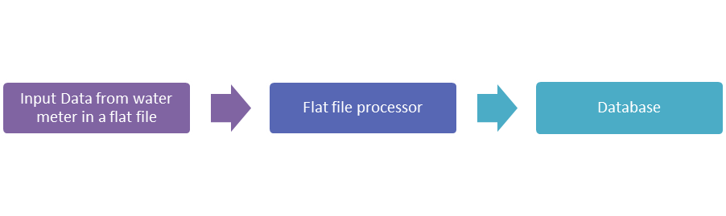

Below diagram shows flow of this application. It talks about:

1. How data from sensor is retrieved and stored into database.
2. Different UI screens
3. WCF services which process the data and display result

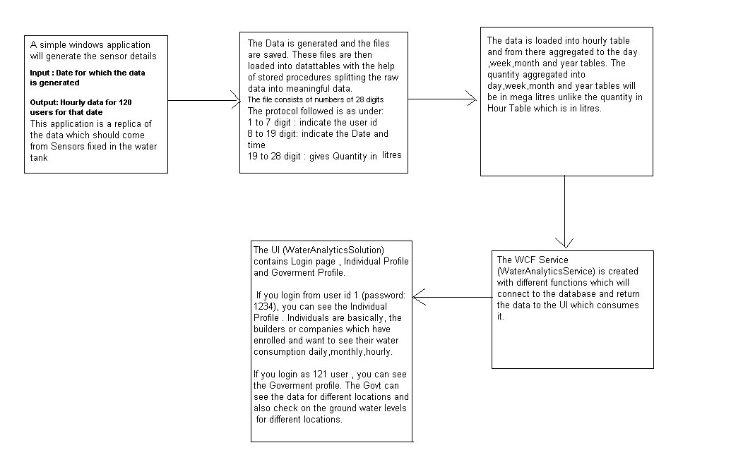

Technical Architecture -

Technical architecture of the application is as shown below: